CLOUD COMPUTING ANF FOG COMPUTING



Highlights:

* What is cloud computing?
* Types and benefits
* What is fog computing ?
* Fog computing vs Cloud computing
* Edge computing vs cloud computing

What is Cloud Computing?

Cloud computing is the on-demand availability of computer system or IT resources , including servers ,data storage , networking ,software and so on , hosted at a remote data centre managed by a cloud services provider. The main purpose of this technology is to offer faster reliable access , flexible resources and elastic scalability .

Cloud computing is everywhere ranging from your Google Gmail through Google Drive , Sheets ,Docs, Microsoft Azure, to Apple iCloud ,etc. In the most simplest of terms , cloud computing refers to the access and storage of data over the internet instead of your computer’s hard drive . No matter where you are , you can make use of the cloud services at whim. Whether we realize or not we most likely make use of the cloud technology in our daily lives.

**Key characteristics of cloud computing are:**

* On-demand availability
* Omnipresent network access
* Resource pooling
* Flexibility ,elasticity and scalability
* Measured Service

Types of Cloud Computing

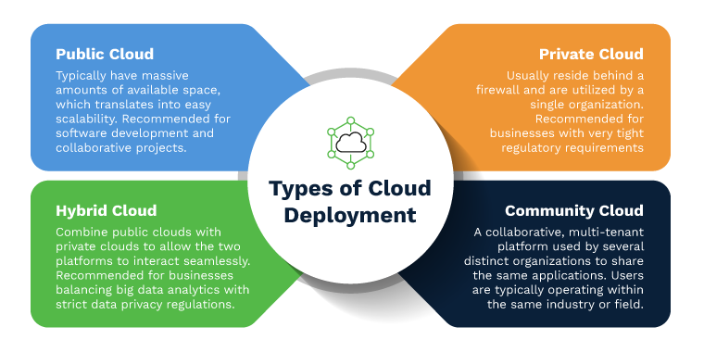

To be able to utilize cloud services , we first need to determine the type of cloud deployment that our cloud services will be implemented on . Cloud deployment basically describes how the cloud is implemented , hosted and who can access it.

Three different ways to deploy a cloud are:

PUBLIC CLOUD:

Public cloud is one which is managed by a third party provider and the resources like storage , hardware and network devices by multiple organizations using the internet. Public clouds have huge amount of space and provide for convenient flexibility and scalability as well . Some of the public cloud examples are Microsoft Azure , Amazon Web Services , Google Gmail , etc .These companies provide both services and infrastructure to the customers.

PRIVATE CLOUD:

Private cloud is a type of cloud compuing service in which the resources are dedicated to and can be accessed exclusively over an internal network , that is a single user or a particular organization.